**Assignment -3**

Cloud object storage and Watson assistant

|  |  |
| --- | --- |
| Assignment Date | 30 September 2022 |
| Student Name | Mr.S.Lumin Titus |
| Student Roll Number | 811319104013 |
| Maximum Marks | 2 Mark |

**Question-1:**

Create a Bucket in IBM object storage

**Solution:**

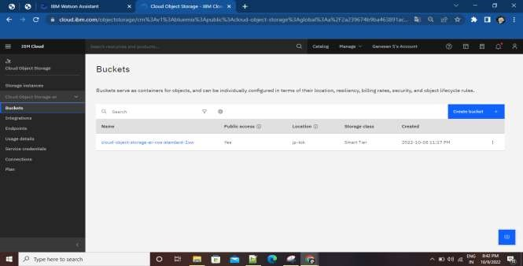

**Question-2:**

**Upload an 5 images to ibm object storage and make it public. Write html code to displaying all the 5 images.**

**Solution:**

**Html code:**

**<!DOCTYPE html>**

**<html>**

**<head>**

**<link rel="stylesheet" href="https://cloud-object-storage-er-cos-standard-1xw.s3.jp-tok.cloud-objectstorage.appdomain.cloud/new.css">**

**</head>**

**<body>**

**<h1>This images are from the cloud object storage</h1>**

**<div class="grid-container">**

**<div class="item1"><img src="https://cloud-object-storage-er-cos-standard-1xw.s3.jp-tok.cloud-objectstorage.appdomain.cloud/1.jpg" alt="Girl in a jacket"></div>**

**<div class="item2"><img src="https://cloud-object-storage-er-cos-standard-1xw.s3.jp-tok.cloud-objectstorage.appdomain.cloud/2.jpg" alt="Girl in a jacket"></div>**

**<div class="item3"><img src="https://cloud-object-storage-er-cos-standard-1xw.s3.jp-tok.cloud-objectstorage.appdomain.cloud/3.jpg" alt="Girl in a jacket"></div>**

**<div class="item4"><img src="https://cloud-object-storage-er-cos-standard-1xw.s3.jp-tok.cloud-objectstorage.appdomain.cloud/4.jpg" alt="Girl in a jacket"></div>**

**<div class="item5"><img src="https://cloud-object-storage-er-cos-standard-1xw.s3.jp-tok.cloud-objectstorage.appdomain.cloud/5.jpg" alt="Girl in a jacket"></div>**

**</div>**

**</body>**

**<**

**/html**

**>**

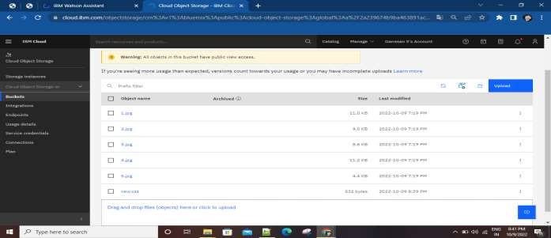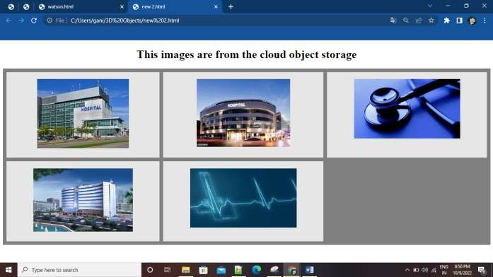

**Question-3:**

Upload a css page to the object storage and use the same page in your html code.

Solution:

New.css uploaded to the object storage and used the same page in html code

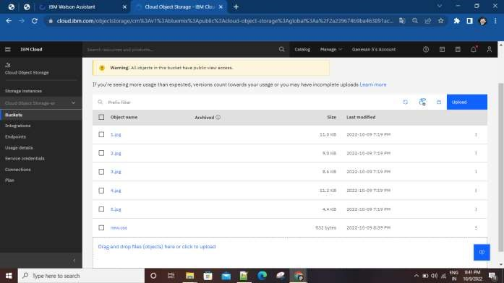

Css page used in html page



**Question-4:**

Design a Chabot using IBM Watson assistant for hospital. Ex: User come the query to know the braches for that hospital in your city. Solution:

URL for: https://web-

chat.global.assistant.watson.appdomain.cloud/preview.html?backgroundImageURL=https%3A%2F%2Fausyd.assistant.watson.cloud.ibm.com%2Fpublic%2Fimages%2Fupx-0516420a-a54c-4626-b459-

481c71f5ac41%3A%3A512d2748-7659-4d70-ba79-81fcedac9d3b&integrationID=0b305951-d464-4f72-9cc7-

938932287427&region=au-syd&serviceInstanceID=0516420a-a54c-4626-b459-481c71f5ac41

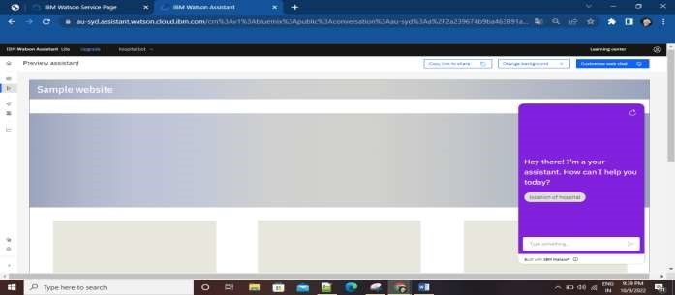

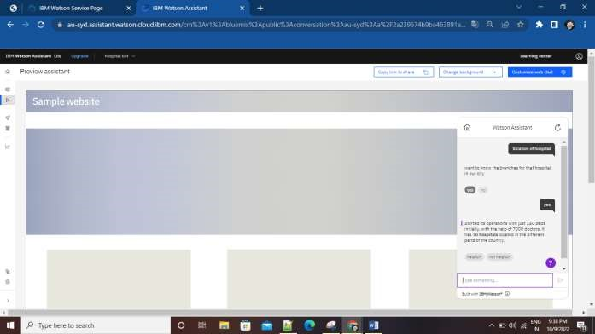

**Question-5:**

Create Watson assistant service with 10 steps and use 3 conditions in it. Load that script in html page Solution:

<!DOCTYPE html>

<html>

<head>

<link rel="stylesheet" href="https://cloud-object-storage-er-cos-standard-1xw.s3.jp-tok.cloud-objectstorage.appdomain.cloud/new.css">

</head> <script> window.watsonAssistantChatOptions = { integrationID: "0b305951-d464-4f72-9cc7-938932287427", // The ID of this integration. region: "au-syd", // The region your integration is hosted in. serviceInstanceID: "0516420a-a54c-4626-b459-481c71f5ac41", // The ID of your service instance.

onLoad: function(instance) { instance.render(); }

};

setTimeout(function(){ const t=document.createElement('script');

t.src="https://web-chat.global.assistant.watson.appdomain.cloud/versions/" +

(window.watsonAssistantChatOptions.clientVersion || 'latest') + "/WatsonAssistantChatEntry.js"; document.head.appendChild(t);

});

</script>

<body>

<h1>This images are from the cloud object storage</h1>

<div class="grid-container">

<div class="item1"><img src="https://cloud-object-storage-er-cos-standard-1xw.s3.jp-tok.cloud-objectstorage.appdomain.cloud/1.jpg" alt="Girl in a jacket"></div>

<div class="item2"><img src="https://cloud-object-storage-er-cos-standard-1xw.s3.jp-tok.cloud-objectstorage.appdomain.cloud/2.jpg" alt="Girl in a jacket"></div>

<div class="item3"><img src="https://cloud-object-storage-er-cos-standard-1xw.s3.jp-tok.cloud-objectstorage.appdomain.cloud/3.jpg" alt="Girl in a jacket"></div>

<div class="item4"><img src="https://cloud-object-storage-er-cos-standard-1xw.s3.jp-tok.cloud-objectstorage.appdomain.cloud/4.jpg" alt="Girl in a jacket"></div>

<div class="item5"><img src="https://cloud-object-storage-er-cos-standard-1xw.s3.jp-tok.cloud-objectstorage.appdomain.cloud/5.jpg" alt="Girl in a jacket"></div>

</div>

</body>

</html> Output:

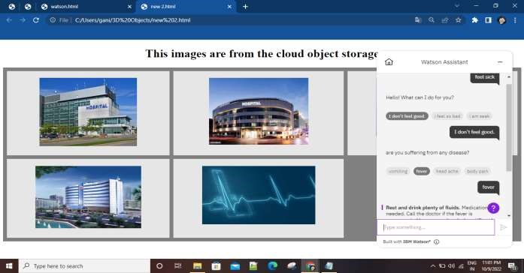

URL for chatbot: [https://web-](https://web-chat.global.assistant.watson.appdomain.cloud/preview.html?backgroundImageURL=https%3A%2F%2Fau-syd.assistant.watson.cloud.ibm.com%2Fpublic%2Fimages%2Fupx-0516420a-a54c-4626-b459-481c71f5ac41%3A%3A512d2748-7659-4d70-ba79-81fcedac9d3b&integrationID=0b305951-d464-4f72-9cc7-938932287427&region=au-syd&serviceInstanceID=0516420a-a54c-4626-b459-481c71f5ac41)

[chat.global.assistant.watson.appdomain.cloud/preview.html?backgroundImageURL=https%3A%2F%2Fausyd.assistant.watson.cloud.ibm.com%2Fpublic%2Fimages%2Fupx-0516420a-a54c-4626-b459-](https://web-chat.global.assistant.watson.appdomain.cloud/preview.html?backgroundImageURL=https%3A%2F%2Fau-syd.assistant.watson.cloud.ibm.com%2Fpublic%2Fimages%2Fupx-0516420a-a54c-4626-b459-481c71f5ac41%3A%3A512d2748-7659-4d70-ba79-81fcedac9d3b&integrationID=0b305951-d464-4f72-9cc7-938932287427&region=au-syd&serviceInstanceID=0516420a-a54c-4626-b459-481c71f5ac41)

[481c71f5ac41%3A%3A512d2748-7659-4d70-ba79-81fcedac9d3b&integrationID=0b305951-d464-4f72-9cc7938932287427&region=au-syd&serviceInstanceID=0516420a-a54c-4626-b459-481c71f5ac41](https://web-chat.global.assistant.watson.appdomain.cloud/preview.html?backgroundImageURL=https%3A%2F%2Fau-syd.assistant.watson.cloud.ibm.com%2Fpublic%2Fimages%2Fupx-0516420a-a54c-4626-b459-481c71f5ac41%3A%3A512d2748-7659-4d70-ba79-81fcedac9d3b&integrationID=0b305951-d464-4f72-9cc7-938932287427&region=au-syd&serviceInstanceID=0516420a-a54c-4626-b459-481c71f5ac41)

URL for webpage: https://cloud-object-storage-er-cos-standard-1xw.s3.jp-tok.cloud-objectstorage.appdomain.cloud/new%202.html